Technical Design Documentation

I have been asked to create a website for Venue Cymru that advertises some of it’s shows, displays some services on offer, among other things. I have incorporated a mailing list popup, I advertise their shows with links to their official website to purchase tickets, and more!

The program used to design the website is called Figma. This includes all designs and prototyping for the project.

## Design Candidate 1

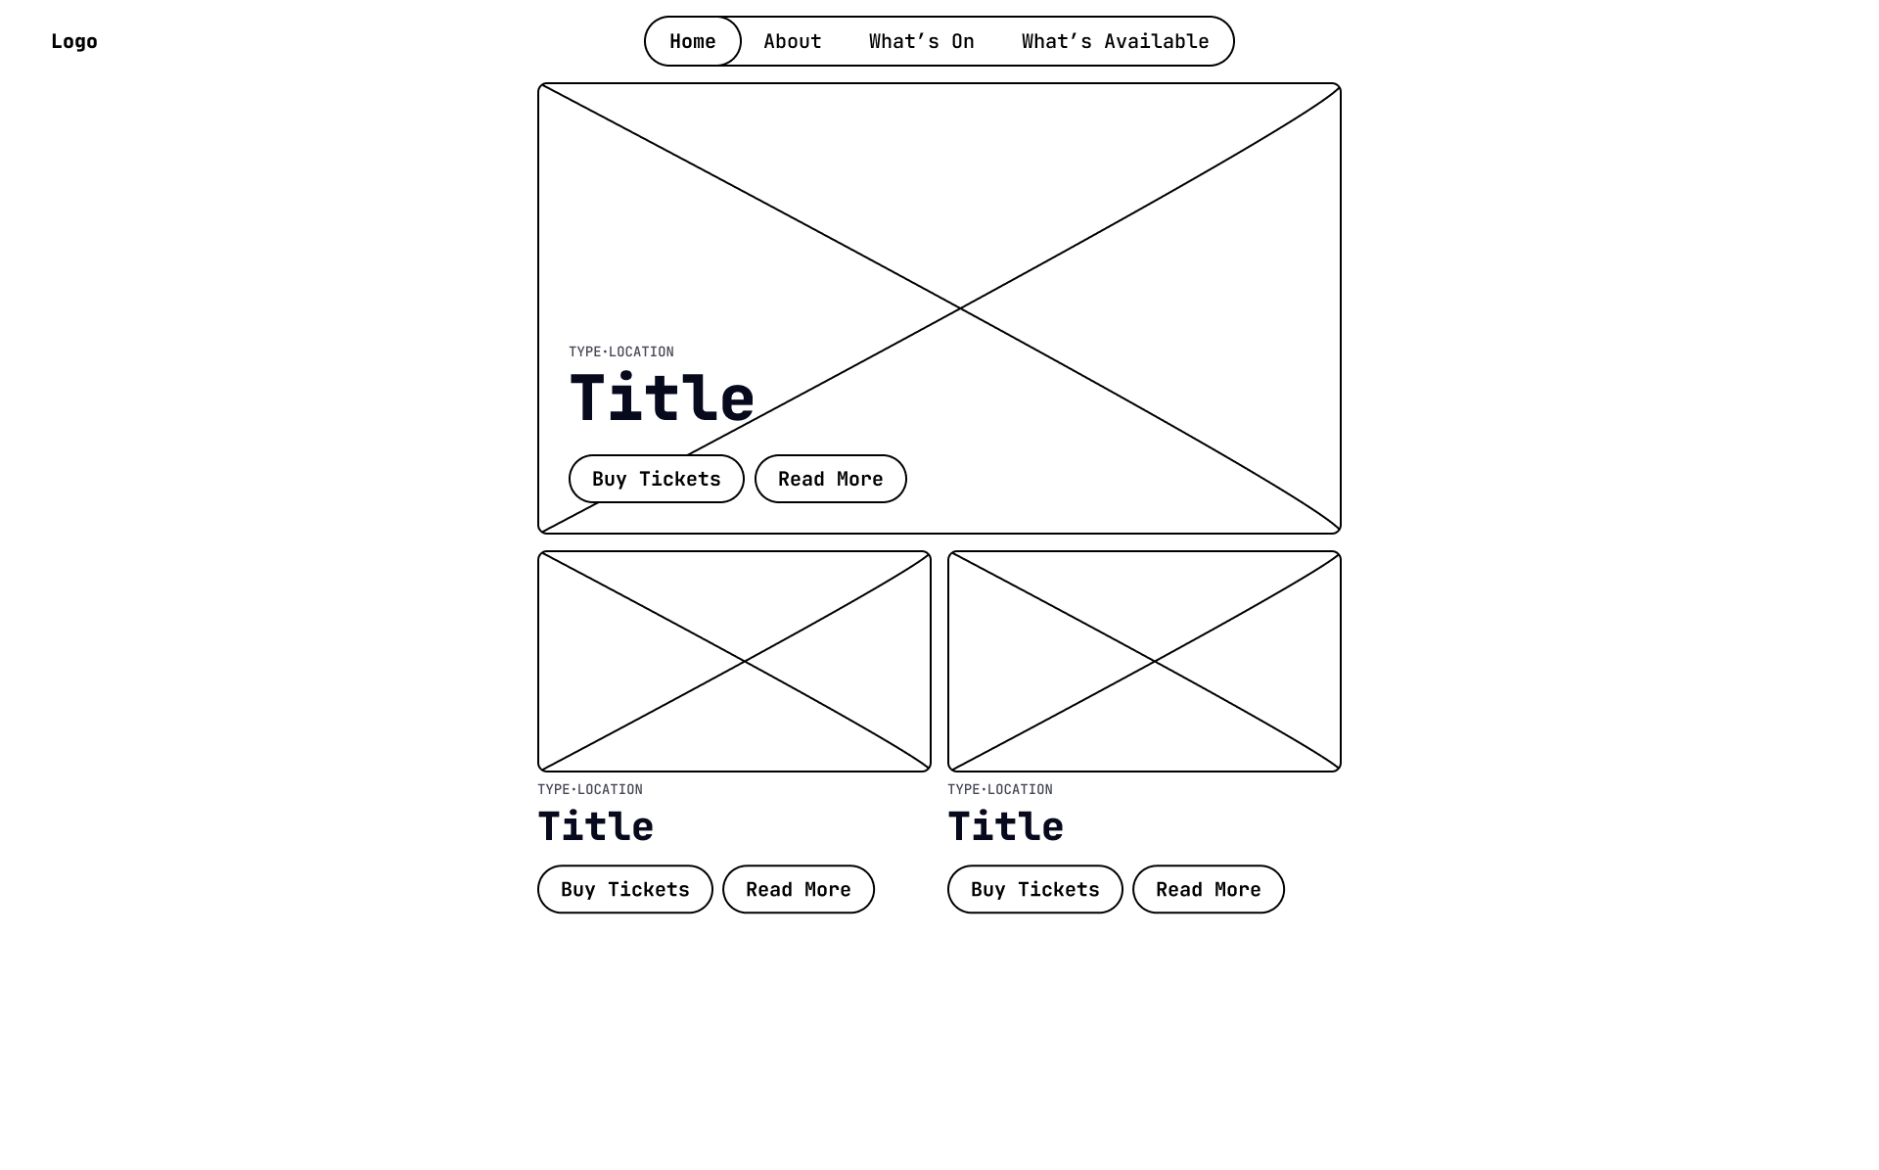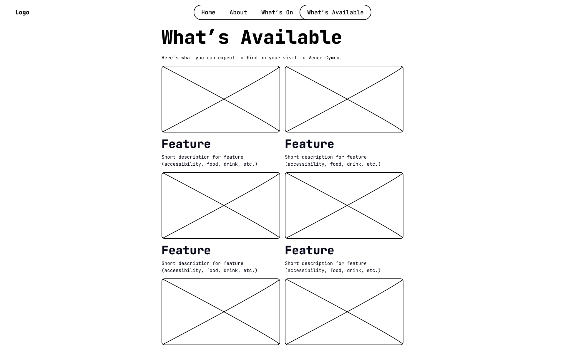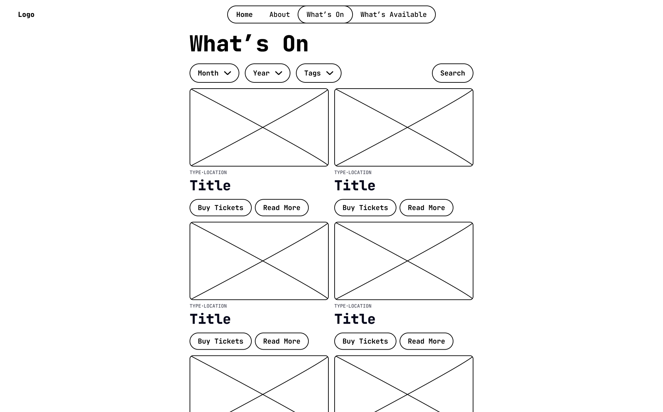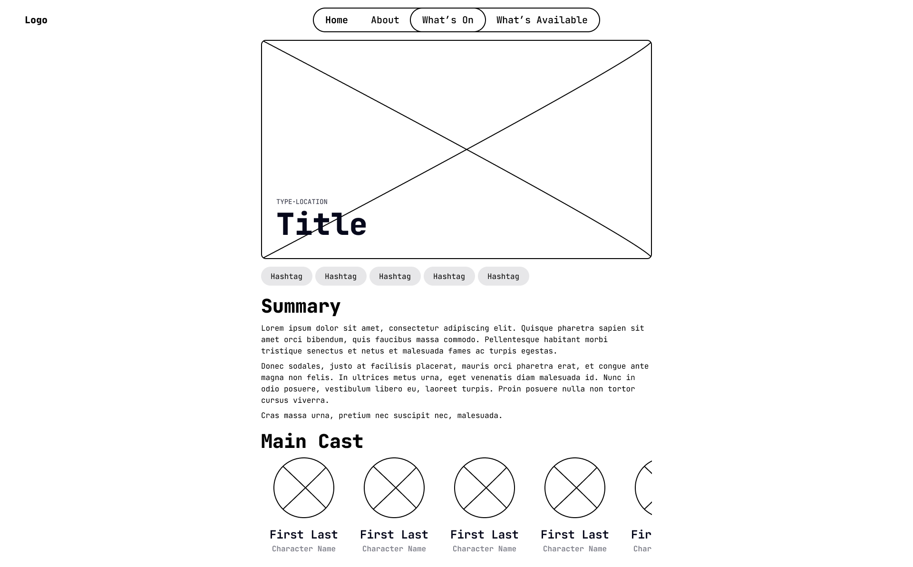

|  |  |  |  |
| --- | --- | --- | --- |
|  |  |  |  |

## Design Candidate 2

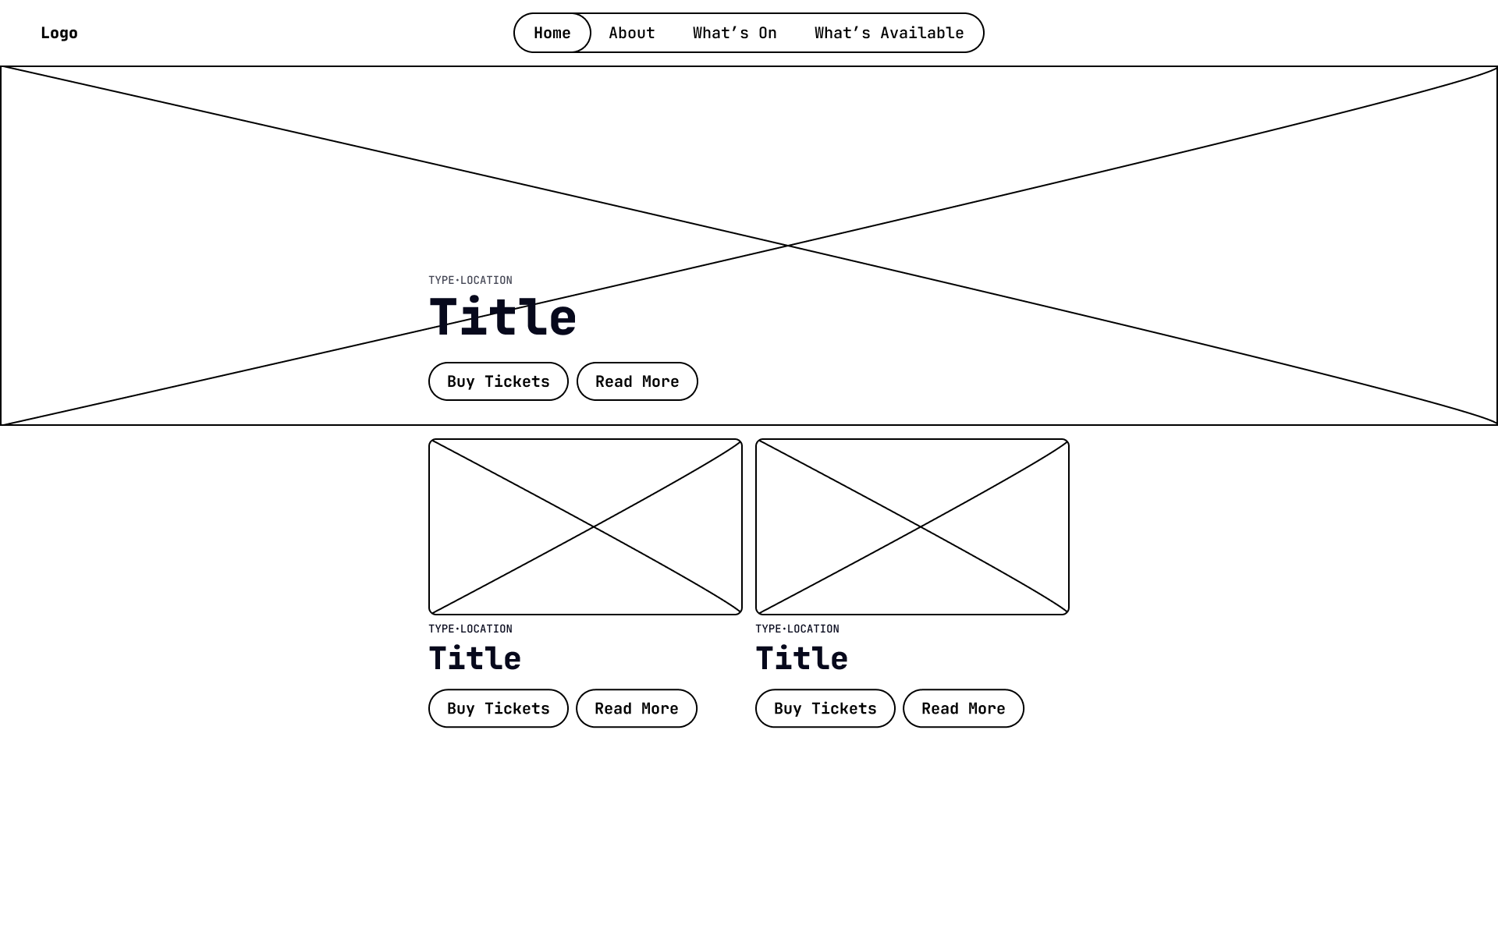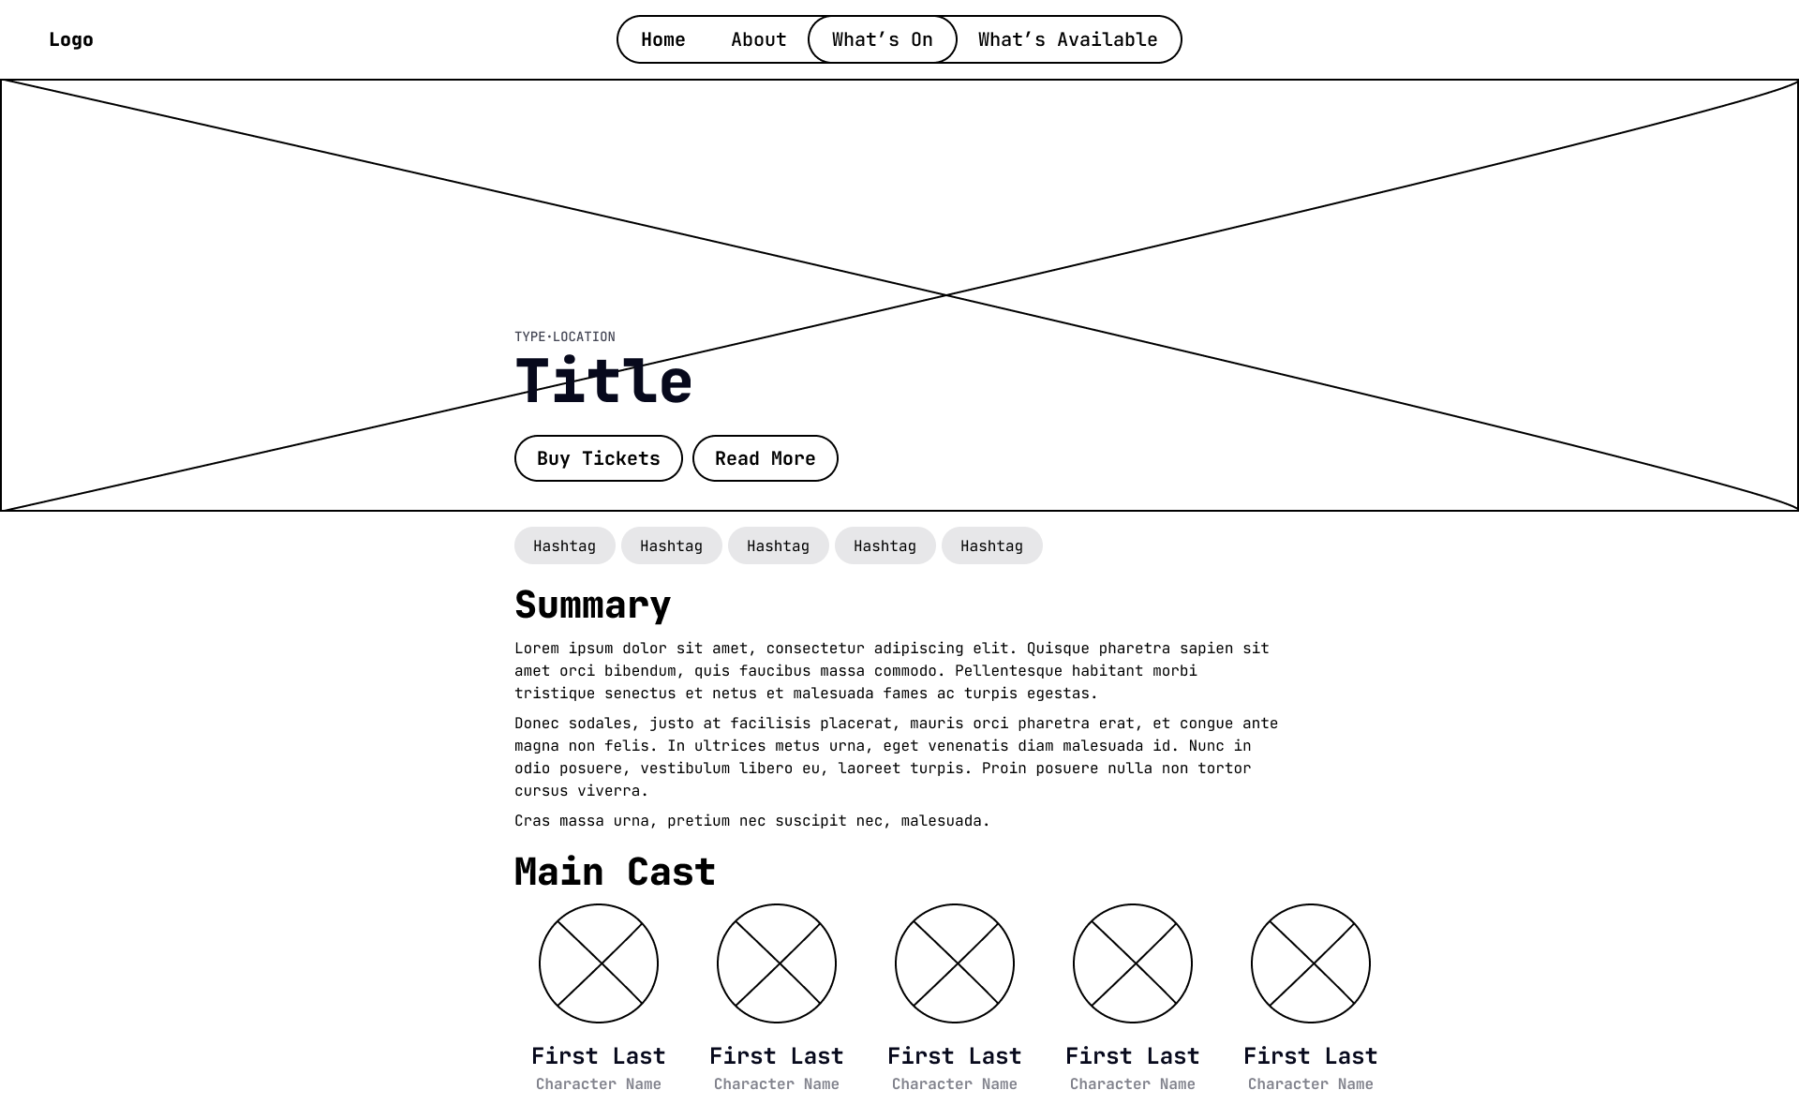

|  |  |  |  |
| --- | --- | --- | --- |
|  |  |  |  |

## Feedback

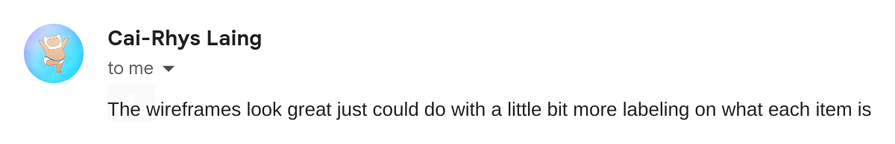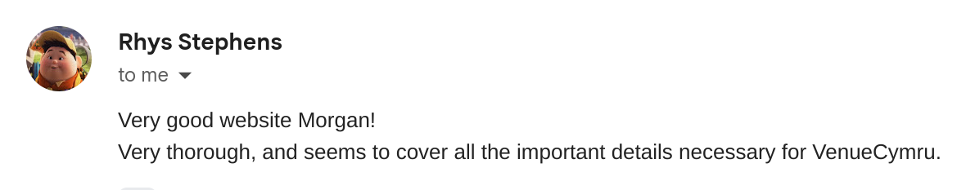

## Design Candidate 1 Revision

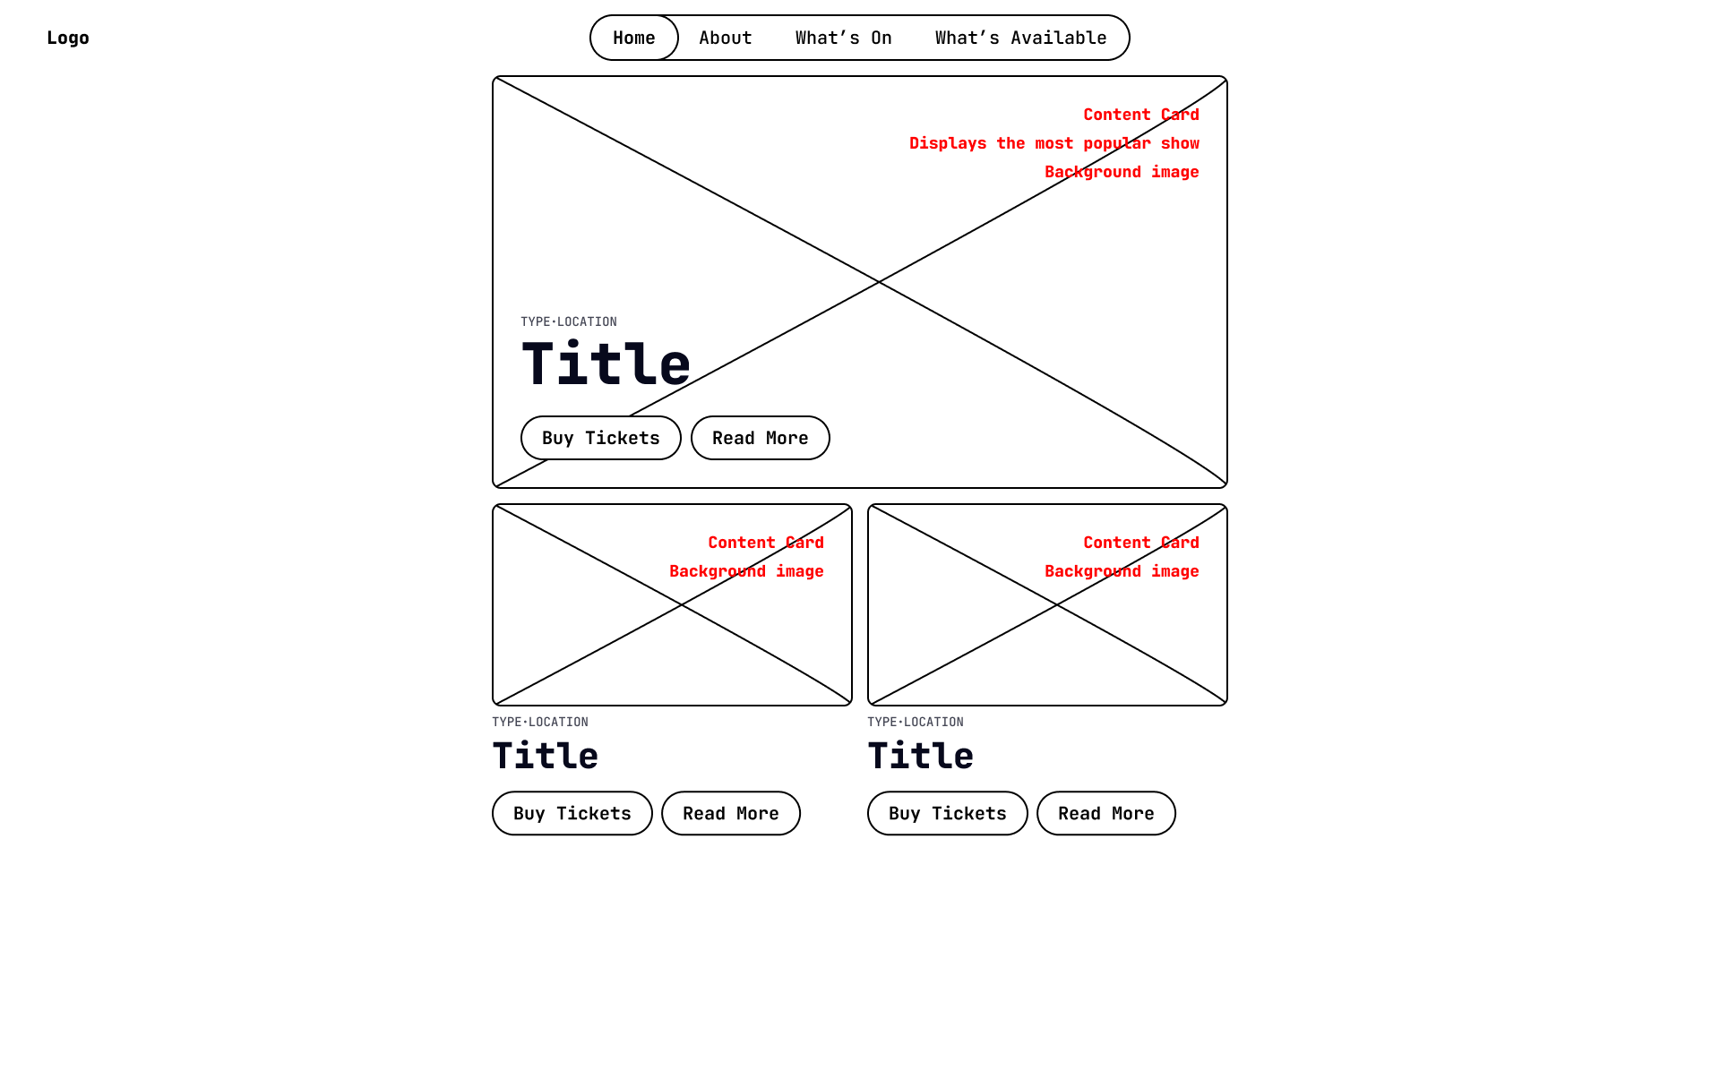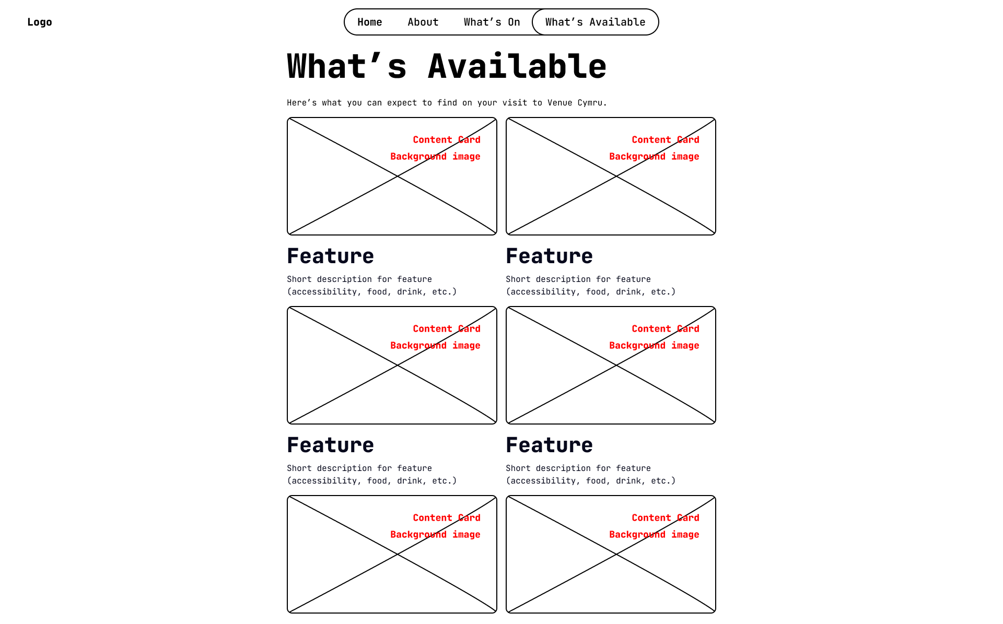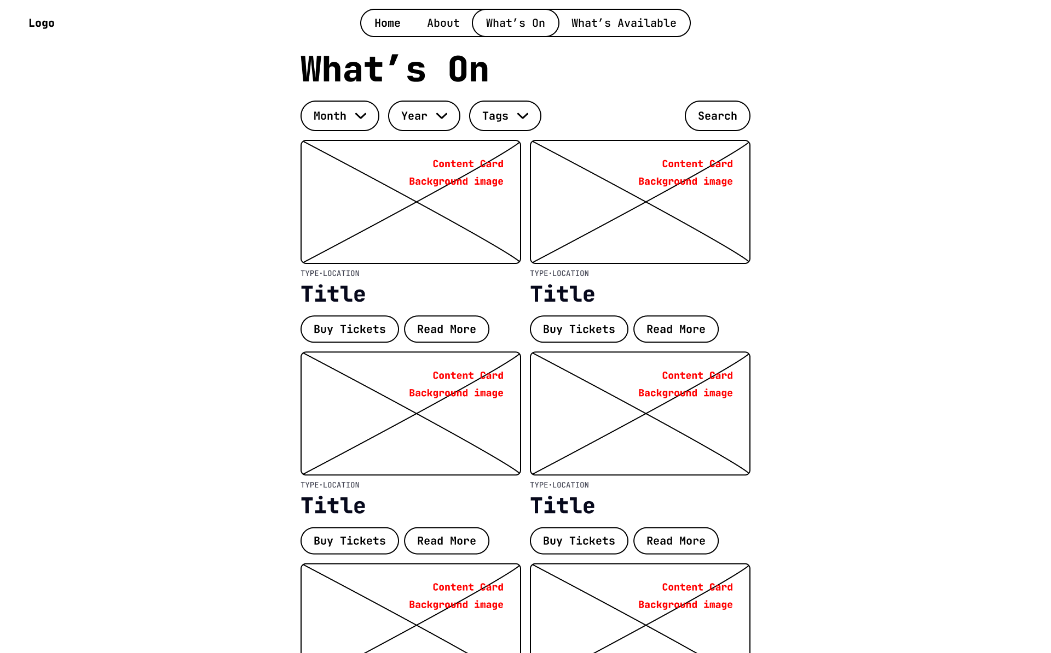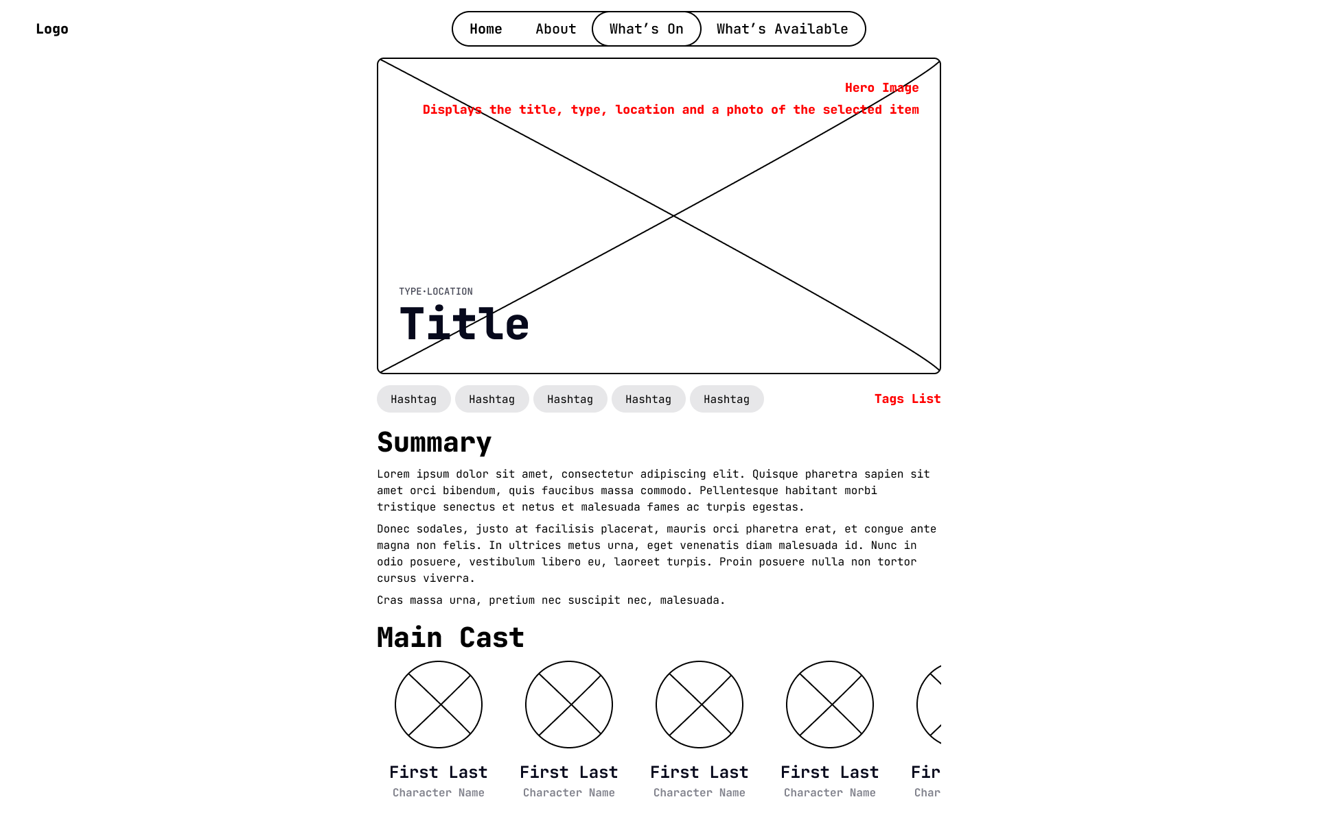

|  |  |  |  |
| --- | --- | --- | --- |
|  |  |  |  |

## Design Candidate 2 Revision

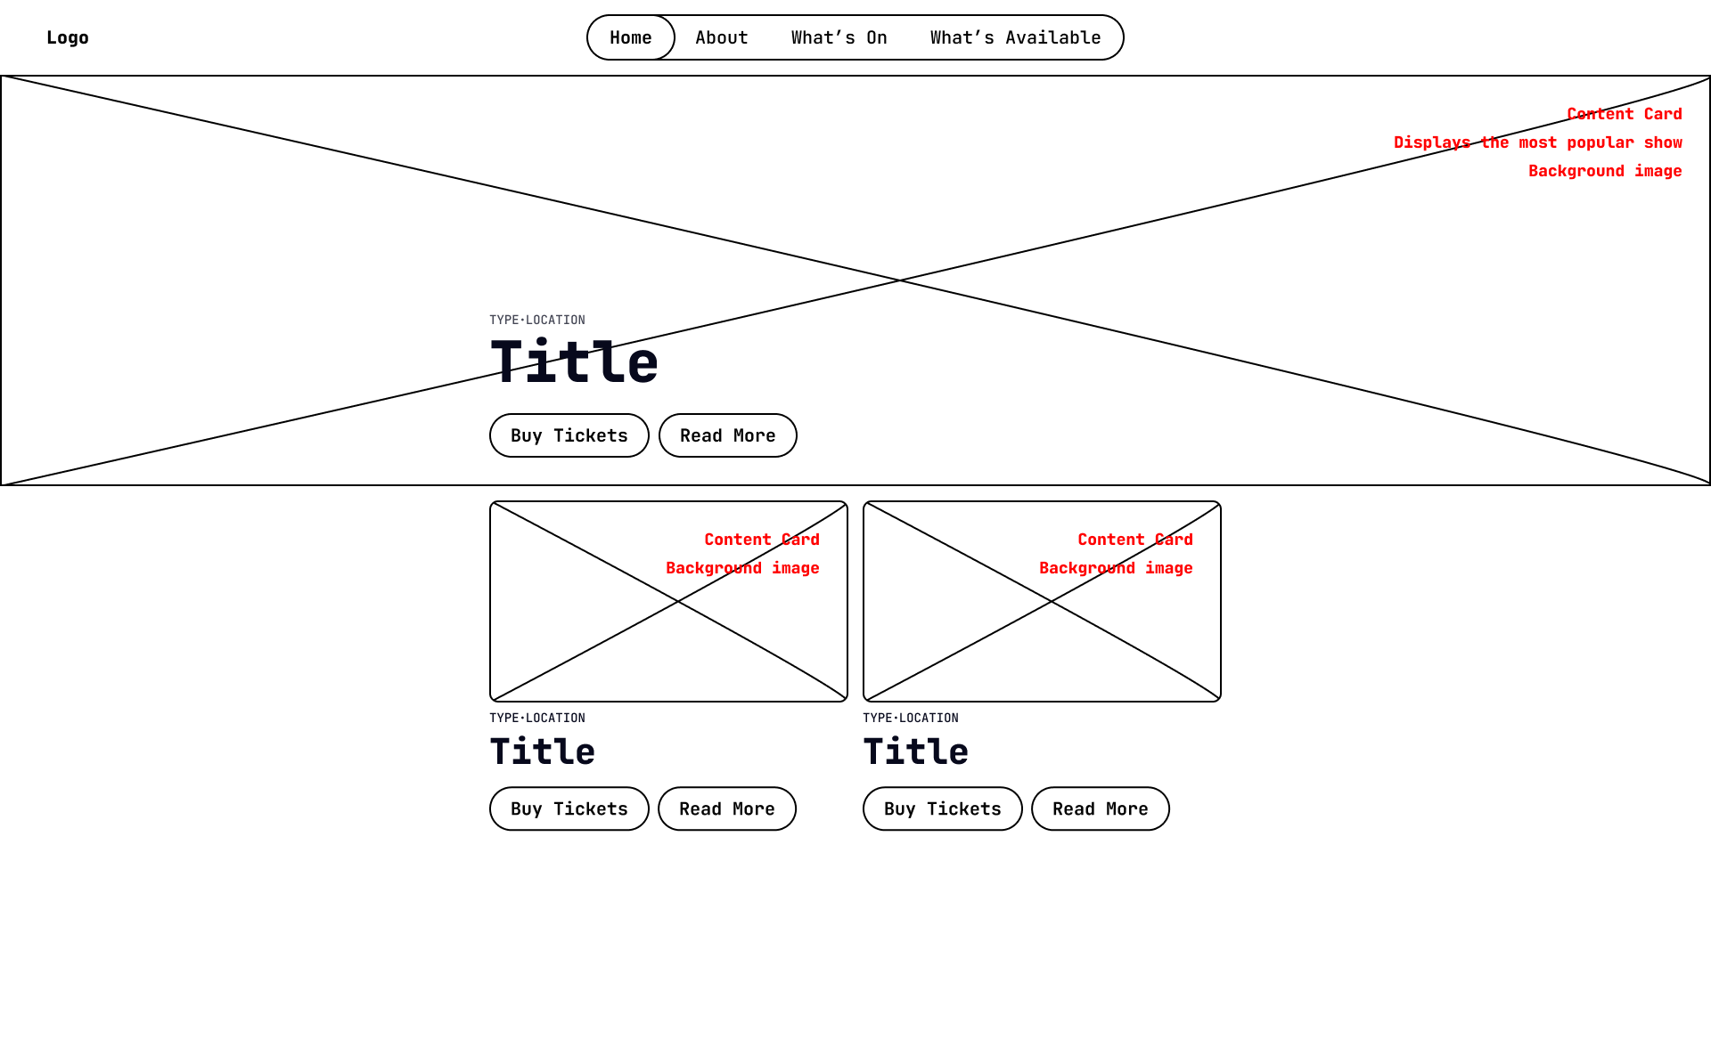

|  |  |  |  |
| --- | --- | --- | --- |
|  |  |  |  |

## Final, Fully-rendered Design

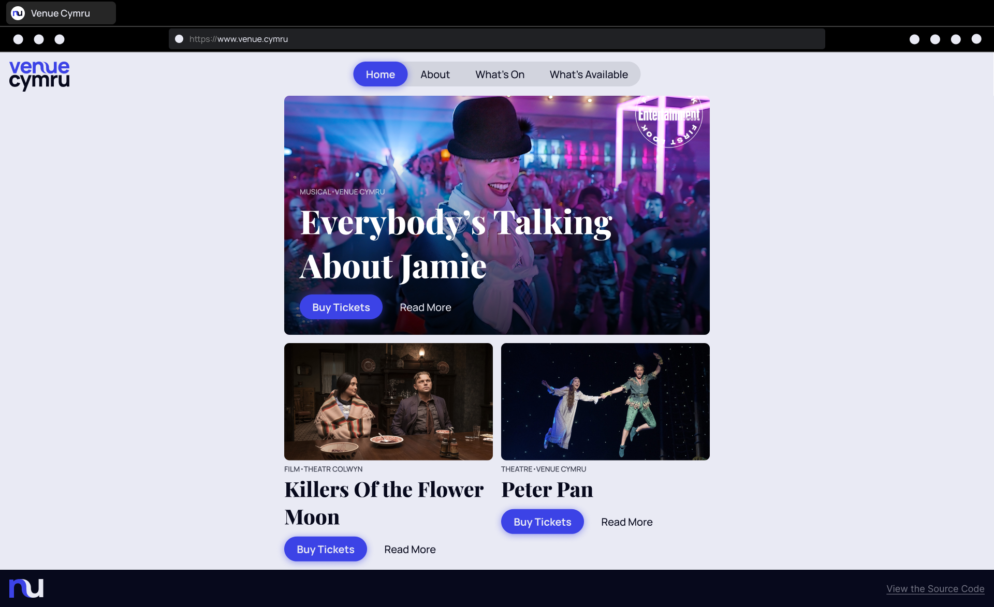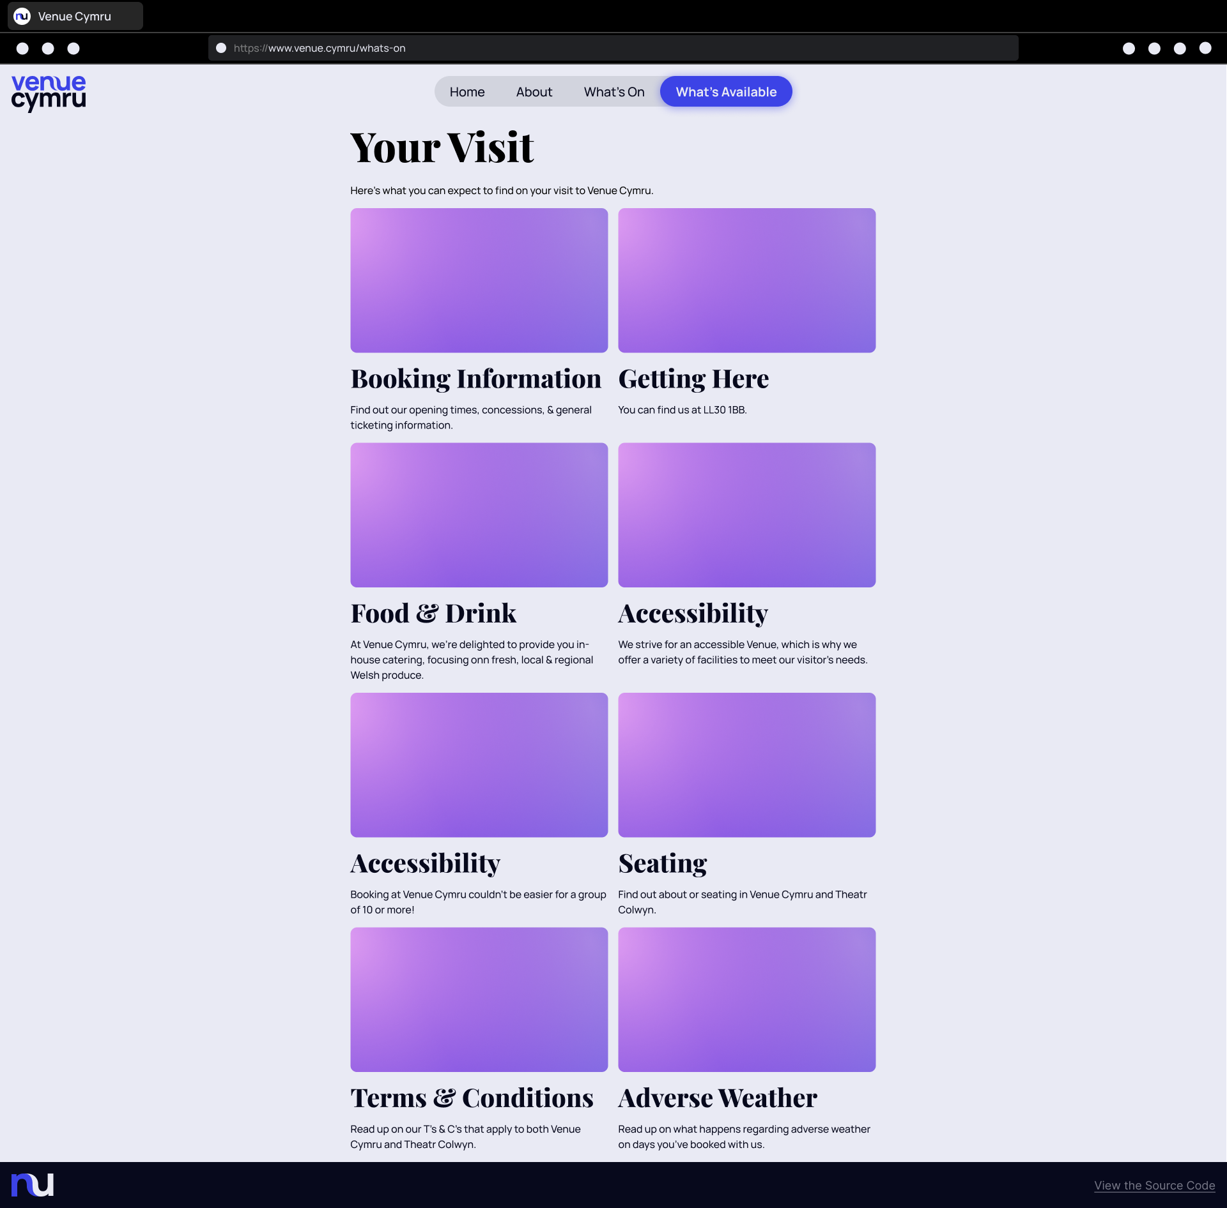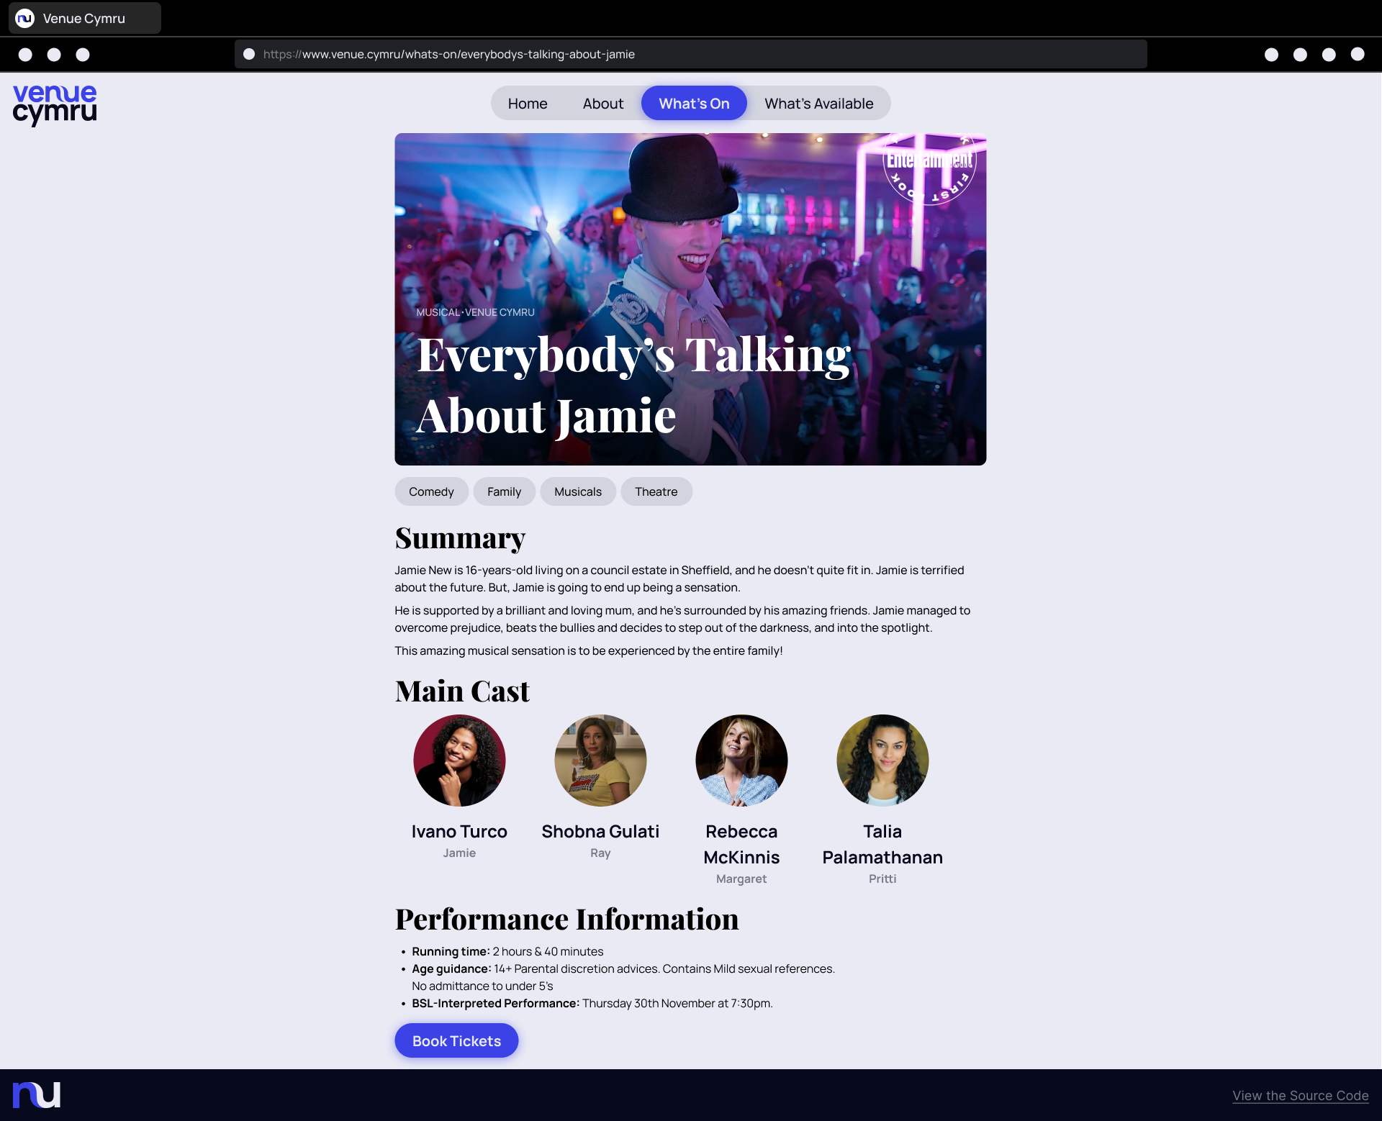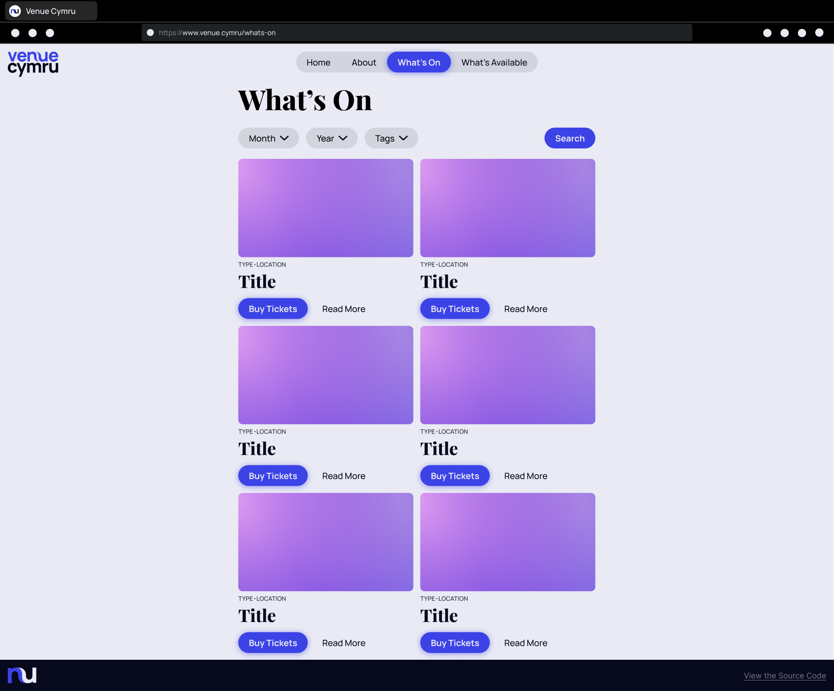

|  |  |  |  |
| --- | --- | --- | --- |
|  |  |  |  |

# Evaluation

## Meeting User Requirements

### A Clear, Concise and Effective Website of 5 pages

I have taken the time to meticulously and carefully design 5 pages for this website that are easy-to-use, clean, and have a good User Experience (UX). On the home page, the website displays one event on the top as a wide banner. This banner is designed to entice the user and catch their eye, which should keep them on the page for longer. Below, there is a 2-item-wide grid displaying even more shows. Clicking on “Buy Tickets” will automatically direct you to the Venue Cymru site to purchase tickets. And clicking on “Read More” will take you to the information page that I have designed for this website.

The about page contains information about Venue Cymru, including it’s history and how it got to where it is today. There is also an embed of Google Maps with Venue Cymru, ready for people to quickly get directions to the venue.

The What’s On page takes inspiration from the home page’s 2-item-wide grid. It displays all of the available shows that can be accessed from the site.

And the What’s Available bar also contains a 2-item-wide grid that displays different services, such as Catlin’s Cafe bar, Y Review Restaurant, Parking, and more.

And finally, the Read More page contains the same banner style found on the home page. Again, this draws the users eyes towards the page. Below that is a list of tags displayed horizontally, so users can get a quick and easy look at what kind of show to expect. The page contains a summary of the show, the main cast list, an embed of the trailer from YouTube, and some performance information.

The web pages also make use of reactivity, which allows the website to work seamlessly on mobile and desktop. When using the mobile site, all grid items become completely vertical, scrolling items, and the navigation bar is placed into a Hamburger menu. The Venue Cymru logo is also turned into the favicon, which depicts the letters “nu,” and for user convenience, the navigation bar is placed at the bottom of the screen.

### Plenty of Interaction

The website uses animations and transitions in places such as the navigation bar to help the website feel alive, responsive, and fluid. Whenever you hover on a navigation bar item, the “Subscribe to our newsletter” button, or any other button or link on the site, the font becomes bolder and, if not already there, a background becomes visible using the company’s accent blue colour. The website also makes use of Google Maps and YouTube video embeds.

Interaction also comes in the form of responsiveness based on your device. The website is fully mobile-compatible and changes many aspects of it’s design to fit a mobile device.

### Adding Users to a Mailing List

In the navigation bar, there is a button to add the user to a newsletter (mailing list). When clicking this button, a dialogue box appears in the centre of the screen. The user can enter their email address. An error will occur if:

* The email entry is empty
* The email is invalid (does not contain the “@” symbol and a dot)

And if the email is successfully validated, the users email is sent to a database. From here, they will receive new newsletter updates. A pop-up will also appear thanking the user for subscribing and close the newsletter dialogue box.